**A summary of reference operating models for Atlantic bluefin tuna management strategy evaluation**

Tom Carruthers[1]

*SUMMARY*

To do last

*KEYWORDS*

*Population dynamics, migration, movement, bluefin*

# Introduction

Management Strategy Evaluation (MSE) uses operating models which represent credible hypotheses for population and fishery dynamics to test the performance of prospective management procedures. These management procedures may encompass a wide range of complexity from conventional stock assessments linked to harvest control rules (Hilborn 2003) through to simple empirical management procedures that calculate catch limits directly from resource monitoring data indices (Geromont and Butterworth 2014a;b, Kell et al. 2015).

MSE applications generally develop operating models from stock assessments that are fitted to data in order to ensure that model assumptions and estimated parameters are empirically credible (Punt et al. 2014, e.g. CCSBT 2011). In the case of Atlantic bluefin tuna, such a model requires enough complexity to capture the core uncertainties regarding Atlantic bluefin tuna dynamics (Fromentin et al. 2014, Leach et al. 2014). These include stock structure (Kell et al. 2012), stock mixing, migration (Fromentin and Lopuszanski 2014) and biases in observed data (e.g. annual catch data). The model should also be able to accommodate a wide range of data that have been collected for Atlantic bluefin tuna including catch rate indices (Abid et al. 2015, Hanke et al. 2015, Kimoto et al. 2015, Lauretta and Brown 2015, Santiago et al. 2015, and Walter 2015), aerial surveys (Bonhommeau et al. 2010), length composition data, larval surveys (Ingram et al. 2015), electronic tagging data (Block et al. 2005) and stock of origin data (Rooker et al. 2014).

A custom operating model known as M3 (Carruthers et al. 2015a) was designed for Atlantic bluefin tuna that could estimate the size, trajectory, seasonal spatio-temporal distribution and movement, simultaneously for both the Western and Eastern Atlantic stocks. The M3 model was fitted to a comprehensive range of (see Carruthers et al. 2015b for summary of operating model data). In this paper I summarize conditioned M3 models (v1.4) that represent the reference operating models of the propose MSE for Atlantic bluefin tuna.

# Methods

## Data

Data description from Matt

## Reference operating models

## Calculating MSY reference points

# Results

## Base operating model predictions

## Variability among reference operating models

## MSE / projections

# Discussion

## Model stability and challenges in the fitting of a multi-stock spatial, seasonal operating model

In many stock assessment settings estimation is complicated by model overparameterization, uninformative data and conflicting data. These problems persist even for the ‘typical assessment’ which has a single area, a single stock and has annual time steps. Fitting seasonal, spatial, multistock operating models for bluefin tuna is particularly challenging because it includes all of the difficulties associated with estimation of the ‘typical assessment’ but these are multiplied by a host of new challenges arising from the additional complexities of movement estimation and multiple stock structure.

A very common problem with typical assessments is that there is poor contrast among

Multstock contrast

Conflicting indices

A significant problem with spatial models is potential for estimating large levels of cryptic biomass: areas where there is no fishing and few data to suggest that there should not be biomass. This is analogous to including a second area in the ‘typical’ assessment that has few data. This serves to complicate estimation of the stock size - productivity ratio for a single stock which is multiplied among stocks in the multi stock assessment setting.

Similarly to the typical assessment, recruitment deviations are penalized in the

MSY reference points are

Estimated current stock

Fit to

In general the model was quite unstable regarding the spatio-temporal distribution of the stocks. Much greater stock

Scale issues – essentially downweights western stock that has a smaller component of catch observations.

Likely to bleed’ into east inflating western stock estimates. Ie small blending leads to large overestimations.

## Conflicting information

Take the increase in vulnerable biomass in the Gulf of St Lawrence inferred by the CPUE indices. The model must generate this increase from solely eastern fish which closely follows the increase in eastern biomass in recent years. This is desirable from the point of view that it can explain flat trend in other western areas (conflicting trends) but undesirable in that it is not well supported by tagging data and stock of origin data that suggest few Eastern fish in the GSL. There is a This is not terribly plausible given the

Fit to increasing CPUE – recruitment, against length composition of younger cohorts. Ie a model overestimate

## General model predictions

At first glance table may appear surprising for a stock that has been of conservation concern blab la. However closer inspection reveals that this result is certainly due to the of the operating model parameterization with respect to natural mortality rate and spawning fraction at age (maturity). In A1 configuration (Table X) the stocks are comparable to moderately lived species such as Atlantic mackerel. In such stocks, MSY reference points relating to stock size are often not that meaningful since just two strong cohorts can easily lead to a stock that

Because abundance indices for the M3 model are over a short time scale (1982+) relative to the exploitation history of the stock, the depletion in the early 1980’s is informed by length composition data alone.

estimates arise from the length composition data

## Specific model predictions

# Acknowledgements

This work was carried out, in part, by TC under the provision of the ICCAT Atlantic Wide Research Programme for Bluefin Tuna (GBYP), funded by the European Union, several ICCAT CPCs, the ICCAT Secretariat and by other entities (see: http://www.iccat.int/GBYP/en/Budget.htm). The contents of this paper do not necessarily reflect the point of view of ICCAT or other funders and in no ways anticipate ICCAT future policy in this area.

# References

Carruthers, T. R., Kimoto, A., Powers, J. E., Kell, L., Butterworth, D. S., Lauretta, M. V., Kitakado, T. 2015a. Structure and estimation framework for Atlantic bluefin tuna operating models. SCRS/2015/179.

Carruthers, T. R., Powers, J. E., Lauretta, M.V., di Natale, A., Kell, L. 2015b. A summary of data to inform operating models in management strategy evaluation of Atlantic bluefin tuna. SCRS/2015/180.

## Table 1. The frequency of movement types of electronic and conventional tags originating from the Atlantic and Strait of Gibraltar. Note that multistage movement types (e.g. ‘To central Med via Balearic’) cannot be determined from conventional tag release and recapture information.

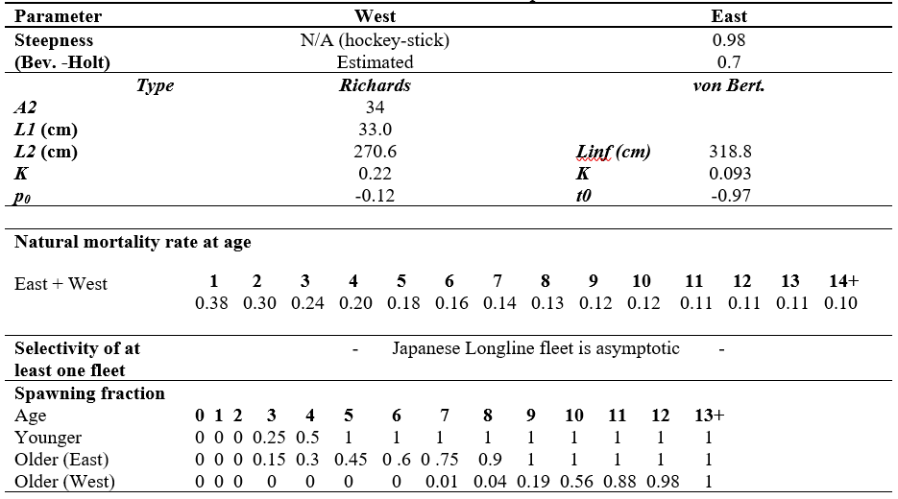

## Table 1. The frequency of movement types of electronic and conventional tags originating from the Atlantic and Strait of Gibraltar. Note that multistage movement types (e.g. ‘To central Med via Balearic’) cannot be determined from conventional tag release and recapture information.

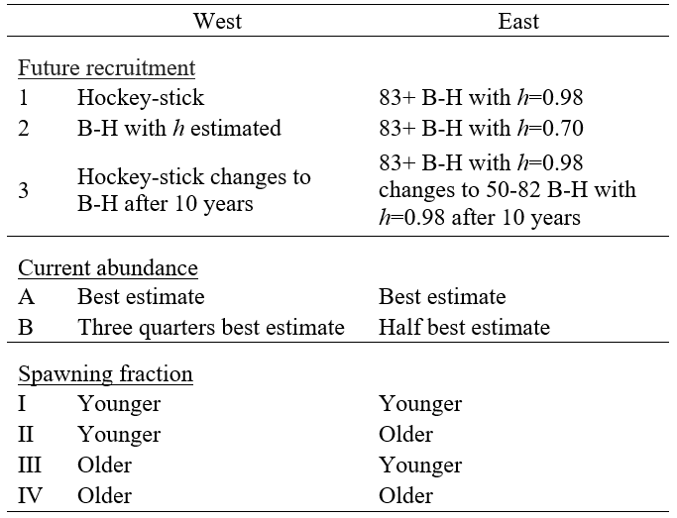

## Table 1. The frequency of movement types of electronic and conventional tags originating from the Atlantic and Strait of Gibraltar. Note that multistage movement types (e.g. ‘To central Med via Balearic’) cannot be determined from conventional tag release and recapture information.

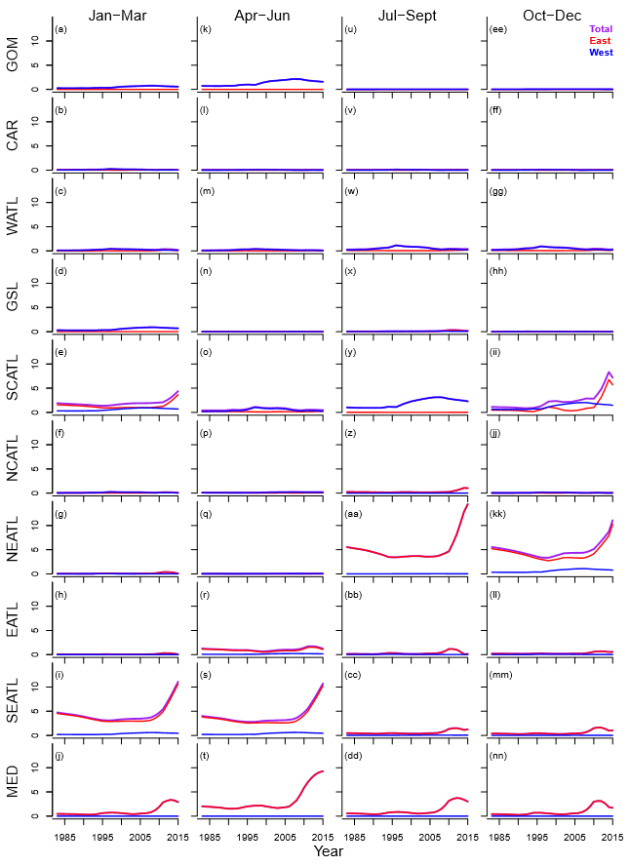

**Figure 1.** Electronic tag tracks for all tags entering the Mediterranean originating in the Atlantic organized by movement type.

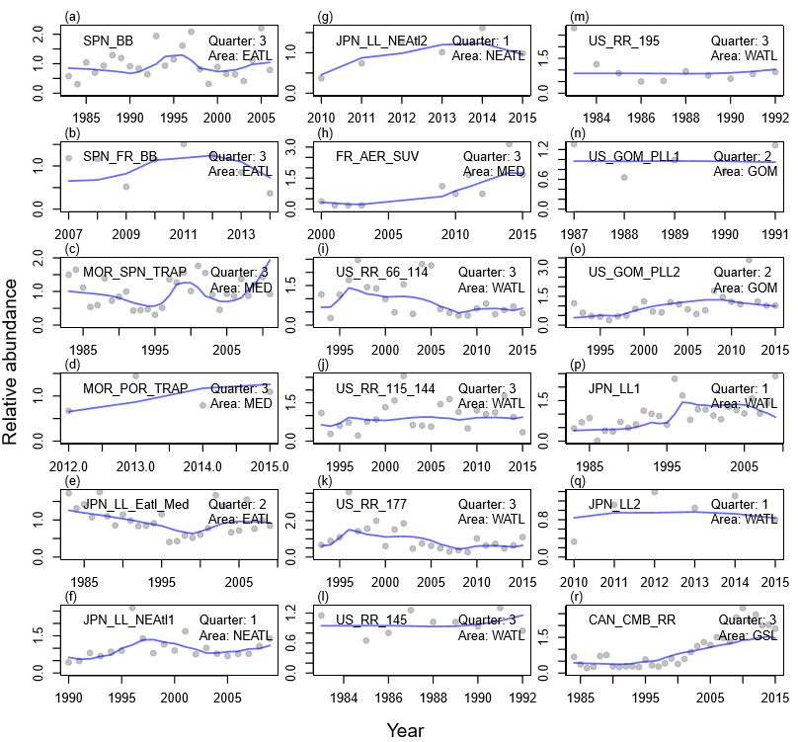

**Figure 2.** Electronic tag tracks for all tags entering the Mediterranean originating in the Atlantic organized by movement type.

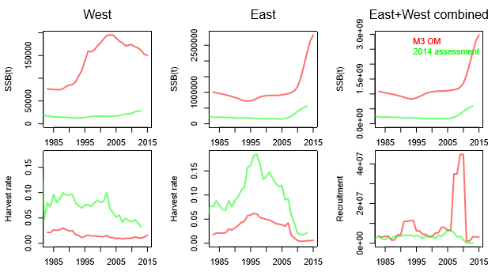

**Figure 3.** Regional comparisons (45deg W) with 2014 stock assessment. Note that annual estimates from the operating model are calculated from weighted average of the seasonal predictions. Harvest rates from the operating model are based on total stock biomass (not vulnerable biomass which is ﬂeet speciﬁc, and hence may not be comparable with assessments).

**Figure 4**. Heat map of daily electronic tag density.

Figure 5. Origin (western areas) of electronic and conventional tags entering the Mediterranean

Figure 6. Origin (Eastern areas) of electronic and conventional tags entering the Mediterranean

1. IOF, 2202 Main Mall, University of British Columbia, Vancouver, B.C., Canada, V6T 1Z4. [t.carruthers@oceans.ubc.ca](mailto:t.carruthers@oceans.ubc.ca)